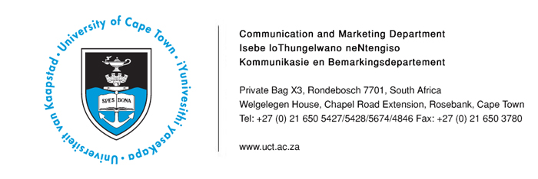
15 April 2014

UCT experts available for comment on 2014 elections

The following experts at the University of Cape Town are available for comment on the forthcoming national general elections, which will take place on 7 May 2014.

Name | Department | Contact Details | Area of Expertise
Dr Ibrahim Saleh | Senior Lecturer, Centre for Film and Media Studies and Convenor for the Political Communication Programme | Tel: 021 650 4837  Ibrahim.Saleh@uct.ac.za | Political communication  Young democracies  Spin doctoring  Sacred duty of voting
Professor Robert Mattes | Professor of Political Studies and Director of the Democracy in Africa Research Unit | Tel: 021 650 3827  Robert.Mattes@uct.ac.za | Comparing SA’s democracy to other young democracies  When is a democracy grown-up – how long does it take?  Can we influence the quality of SA’s future democracy?
Ms Cal Volks | Director: HIV/AIDS Unit | Tel: 021 650 1008  cal.volks@uct.ac.za | Does the “born free” generation exist in South Africa?
Dr Ariane de Lannoy | Senior Researcher: Children’s Institute | Tel: 021 689 5404  ariane.delannoy@uct.ac.za | Youth’s experiences of and participation in democracy

ENDS
Issued by: UCT Communication and Marketing Department

Kemantha Govender
Media Liaison Officer
Communication and Marketing Department
University of Cape Town
Welgelegen, Upper Chapel Road Extension, Rosebank
Tel: (021) 650 5672 Fax: (021) 650 3780
Cell: (084) 737 6522
E-mail: kemantha.govender@uct.ac.za
Website: www.uct.ac.za

