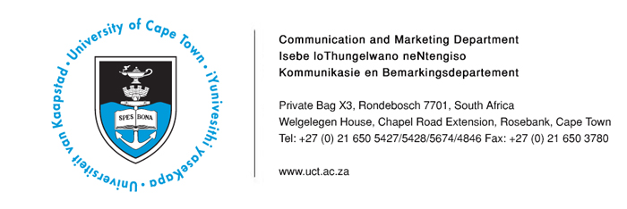
14 April 2014

Upcoming UCT events
- Keith Grainger Memorial UCT Open Squash Championships: Mr Kerr Rogers to speak about what students are doing to raise funds and create awareness about cancer prevention.
- Future Foreshore student exhibition: UCT students propose innovative and creative proposals for the future of the City of Cape Town’s Foreshore and its unfinished freeways.

Date | Event/Topic | Highlights/Speakers | Contact
25 April – 1 May | 9th Keith Grainger Memorial UCT Open Squash Championships  Venue: UCT Sports Centre, Upper Campus. | The UCT tournament is named after Keith Grainger, a former UCT student who died of cancer. His contribution to squash at UCT between 1999 and 2001 was immense, despite his reliance on a prosthetic leg. This year’s tournament will again aim to raise funds for and create awareness around cancer prevention. All donations received will be handed over to the Cancer Association of South Africa.  Kerr Rogers, Sports Coordinator at UCT, said: “The UCT Squash Club has encouraged the local community to get involved and support the event on and off the court. Spectators will be guaranteed plenty of drama on the court, with SA’s best players matching their skills against players ranked among the top 100 in the world.” | Kemantha Govender  Tel: 021 650 5672  Cell: 084 737 6522  Kemantha.Govender@uct.ac.za
14 April | Future Foreshore student exhibition  Time: 18h00  Venue: City Hall, 2nd floor, Darling Street, Cape Town | Students from UCT’s Faculty of Engineering and the Built Environment will exhibit their proposals for the World Design Capital project:” Future Foreshore”. Over the course of 2013, the students were tasked with developing innovative and creative proposals for the future of the City Foreshore and its unfinished freeways.  UCT’s Professor Francis Petersen, the Dean of the Faculty of Engineering, will be among the speakers at the event. | Mary Hilton  Tel: 021 650 4108  Cell: 073 236 5783  mary.hilton@uct.ac.za

ENDS

Issued by: UCT Communication and Marketing Department

Mologadi Makwela
Media Liaison Officer
Communication and Marketing Department
University of Cape Town
Welgelegen, Upper Chapel Road Extension, Rosebank
Tel: (021) 650 5427 Fax: (021) 650 3780
Cell: (078) 258 3965
E-mail: loga.makwela@uct.ac.za
Website: www.uct.ac.za

