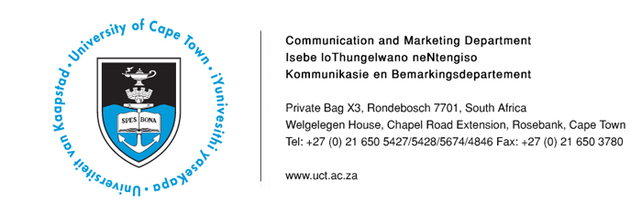14 April 2014
San communities will care for returned land - UCT researcher

Looking at the land claim by the Khomani San and Mier communities on the Kgalagadi Transfrontier Park, University of Cape Town researcher Johane Dikgang has found that land restitution does not necessarily reduce poverty. However, the Khomani San can be trusted to be good environmental stewards, and there is indeed scope to generate revenue that they could share between them and South Africa’s national parks.

Dikgang’s thesis, The economic value of natural resources around the Kgalagadi Transfrontier Park and implications for the Khomani San in South Africa, concluded that the Khomani San must be involved if conservation schemes in the Kgalagadi area are to be successful.

In post-colonial and post-apartheid South Africa, land restitution is described as an emotive and fractious battlefield. It is said that those reluctant for the process to go forward often argue that the historically rightful owners could damage the environment when this land is returned to them. Dikgang’s research has disproved the fears that these communities would be unable to maintain the health of the environment.

Dikgang, who graduated with a PhD in economics from UCT at the end of 2013, explored the delicate balancing act that characterises the Kgalagadi claim: how to balance conservation and beneficiaries’ rights to land and natural resources. As last year marked the centenary of the 1913 Natives Land Act, his thesis is particularly relevant.

Dikgang says the Kgalagadi land claim, unlike some others, was not characterised by a tussle over competing commercial interests. His research explored three core issues: first, whether land restitution helps reduce poverty; second, the value that the Khomani San assign to modern conservation under various land tenure arrangements; and finally, whether there was scope to generate additional revenue through conservation efforts, which could then be shared between the Khomani San and the national parks.

Dikgang says: “We conducted face-to-face surveys in the Kgalagadi area, comparing 100 Khomani San households who used restituted land with another 100 households who did not. These 200 households were drawn from the 320 registered beneficiaries of the Khomani San land claim. Thus, the research restricted the sample to the Khomani San who could plausibly have taken up the offer to use the restituted land.”

The data collected included detailed information on household income, consumption expenditure, access to nature, housing services, farming activities, and land use and
migration patterns.

The primary objective here was to assess whether the Khomani San may generally be expected to be good environmental stewards. “To assess their attitudes towards biodiversity conservation, our study used the contingent valuation study of a plant conservation programme in the Kgalagadi. We wanted to find out which value the Khomani San and Mier communities assigned to biodiversity conservation under three land tenure arrangements: communal land, municipal land, and parkland.

“We found that 92% of the Khomani San respondents supported implementation of the proposed biodiversity conservation programme on communal land, while 79% of these respondents supported implementation of the same programme on either municipal land or inside the park.”

Given that the majority of Khomani San respondents supported the implementation of the proposed biodiversity conservation programme on any one of the land types, Dikgang concluded that the Khomani San people generally derive net positive benefits from the proposed biodiversity conservation programme. As a result, the majority of them would vote for its implementation. In contrast to the San, the Mier community was mainly interested in the economic benefits - job creation and business venture opportunities - that come about because of owning land.

Dikgang says: “The research project’s findings are important because they may provide useful, policy-relevant information that will help well-informed decision making with regards to sustainable resource use, equity and poverty alleviation.”

Dikgang received his BCom and MCom from the Nelson Mandela Metropolitan University in 2005 and 2008 respectively, and joined UCT’s Environmental Policy Research Unit as a Junior Research Fellow in 2008. In 2011, he attended the PhD specialisation course in environmental valuation at the Department of Economics, University of Gothenburg, Sweden.
ENDS
Issued by: UCT Communication and Marketing Department
Riana Geldenhuys
Head: Media Liaison
Communication and Marketing Department
University of Cape Town

Tel: (021) 650 4846 Fax: (021) 650 3780
Cell: (082) 460 5554
Email: riana.geldenhuys@uct.ac.za Website: www.uct.ac.za

