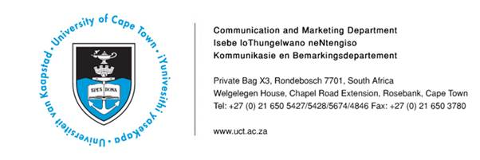
02 April 2014

50% of rape survivors suffer from PTSD – UCT study

A study conducted by University of Cape Town researcher Dr Anastasia Maw examines the psychological impact of rape within the South African context. Dr Maw’s thesis, The psychological impact of rape: A longitudinal study of adult female survivors in the Western Cape, reveals that roughly 50% of rape survivors suffer from post-traumatic stress disorder (PTSD).

Despite the high prevalence of rape in the country, very limited research has until now been conducted on the psychological impact of rape within the South African context.

Through her work at two non-governmental organisations in Cape Town, the Trauma Centre for Survivors of Violence and Torture in Woodstock and Rape Crisis in Observatory, Dr Maw saw the need for research that would contribute to understanding the psychological impact of rape on South African women.

For her thesis, Dr Maw interviewed 64 female rape survivors at the Thuthuzela Care Centre (in Manenberg) at one, four, 12 and 24 weeks after the rape. She conducted psychiatric assessments at each interval. Results, which showed that over half of the women taking part in the study merited a diagnosis of PTSD, are more or less in line with international findings, where just under half of rape survivors suffered from PTSD.

Dr Maw says: “However, the diagnostic category of PTSD is a contested one. At the very least, the diagnosis fails to capture the complex ways in which the aftermath of rape might be experienced by a survivor. A narrow focus on the treatment of PTSD, without a fully considered evaluation of psychological needs, would be likely to fail in terms of providing effective and comprehensive mental healthcare post rape.”

The study revealed that social development needs have an impact on the psychological wellbeing of survivors.

Although the women interviewed by Dr Maw expressed a strong need for counselling, they also communicated various practical needs such as assistance in accessing child support and disability grants, finding jobs, help with completing education and finding safe housing.

While these responses are expressions of social development needs, Dr Maw emphasises that they “impact greatly on psychological wellbeing”. “When you ask women what they actually need, it’s not a space in which they can talk. Women need to live in a context in which there is a greater degree of safety and stability.”

According to Dr Maw, professional intervention in the immediate aftermath of the event of rape might not be helpful for the survivor’s recovery. “There is enough research to show that it’s best to hold off on psychiatric or psychological intervention from professionals, until such time as there has been an opportunity for the person to recover on their own. There appears to an innate recovery process that kicks in automatically after the trauma. In the immediate aftermath, there appears to be a rather strong reaction resulting in a very high level of distress. People would automatically turn to those they trust the most – not strangers and professionals, but their friends and family. If such support isn’t forthcoming, or it isn’t enough over time, then you might have to start considering the need for help from a mental health professional.”

Dr Maw is a clinical psychologist at UCT’s Child Guidance Clinic and holds BA, BSocSc (Hons) and MA (Clinical Psychology) degrees from UCT. She is currently involved in the training of clinical psychologists and received her PhD from UCT in December last year.

ENDS

Issued by: UCT Communication and Marketing Department

Mologadi Makwela
Communication and Marketing Department
University of Cape Town
Tel: (021) 650 5427 Fax: (021) 650 5628
Cell: (078) 258 3965
E-mail: loga.makwela@uct.ac.za
Website: www.uct.ac.za
Follow us on Twitter: @UCT_news

