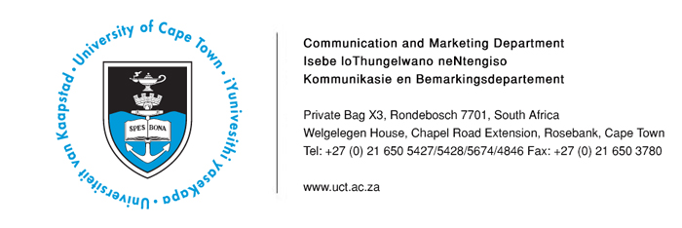
10 March 2014

UCT experts available for comment on Oscar Pistorius trial

The following University of Cape Town academics are available for expert comment on the Oscar Pistorius trial, currently underway in Pretoria.

Name | Department | Contact Details
Professor PJ Schwikkard | Dean of the Faculty of Law | 021 650 2706  pamela.schwikkard@uct.ac.za
Professor Jonathan Burchell | Professor of Criminal Law, Department of Public Law | 021 650 2672  jonathan.burchell@uct.ac.za
Ms Kelly Phelps | Senior Lecturer, Department of Public Law | 021 650 5625  kelly.phelps@uct.ac.za

PLEASE NOTE: Should you need any assistance in reaching these experts, please contact Loga Makwela at 021 650 5427, 078 258 3965 or loga.makwela@uct.ac.za .
ENDS
Issued by: UCT Communication and Marketing Department
Mologadi Makwela
Media Liaison Officer
Communication and Marketing Department
University of Cape Town
Welgelegen, Upper Chapel Road Extension, Rosebank
Tel: (021) 650 5427 Fax: (021) 650 3780
Cell: (078) 258 3965
E-mail: loga.makwela@uct.ac.za
Website: www.uct.ac.za

