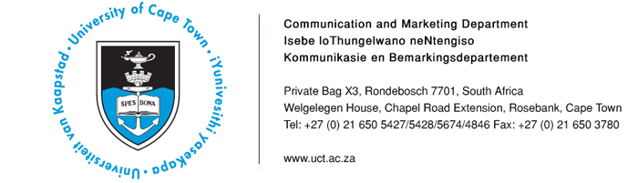
27 January 2014

Upcoming UCT events and interview opportunities
- Associate Professor Adam Haupt to speak about the relationship between hip-hop and post-apartheid politics
- Professor Pierre de Vos to examine the important ways in which South Africa’s Constitution invokes the past
- Dr Christi van der Westhuizen & Dr Zethu Matebeni to explain the politics of sex and the sex of politics
- Professor Steven Robins to talk about “toilet wars” and the politics of sanitation in Cape Town

Date | Event | Highlights/Speakers | Contact
27 – 30 January | UCT Summer School 2014: Hip-hop activism  Time: 17h30  Venue: Kramer Law Building,  Middle Campus, UCT | Associate Professor Adam Haupt of UCT’s Centre for Film and Media Studies and DJ Ready D (ex-Prophets of da City) will examine the role hip-hop has played in engaging young South Africans creatively and politically. It will offer an account of hip-hop’s political orientation in relation to debates about commercial co-option, censorship, gender, race and other identity politics. | Loga Makwela  Tel: 021 650 5427 loga.makwela@uct.ac.za
27 – 29 January | UCT Summer School 2014:  The past is unpredictable - SA Constitution  Time: 19h30  Venue: Kramer Law Building, Middle Campus, UCT | Professor Pierre de Vos, Claude Leon Foundation Chair in Constitutional Governance at UCT’s Department of Public Law, examines the important ways in which South Africa’s Constitution invokes the past, most notably in relation to affirmative action. | Loga Makwela  Tel: 021 650 5427 loga.makwela@uct.ac.za
29 January | UCT Summer School 2014:  In conversation: Politics–sex/sex–politics  Time: 13h00  Venue: Kramer Law Building, Middle Campus, UCT | This conversation will investigate how space in South Africa’s democracy is being carved by and for women and men who do not conform to gender ideas inherited from apartheid. Dr Christi van der Westhuizen, a feminist, author, award-winning political columnist and research associate with UFS’s Institute for Reconciliation  and Social Justice will engage with Dr Zethu Matebeni, activist, author, filmmaker, curator and researcher at UCT’s Institute for Humanities in Africa, on black female sexualities and genders. | Loga Makwela  Tel: 021 650 5427 loga.makwela@uct.ac.za
27 – 31 January | UCT Summer School 2014: Writers researching - Fact and fiction  Time: 17h30  Venue: Kramer Law Building, Middle Campus, UCT | In this course, writers will talk about the research that resulted in their recent novels. Ron Irwin, author of Flat Water Tuesday, will discuss the challenges associated with turning the events of one’s own life into a novel. Helen Moffett, one of the trio behind the Girl Walks In series, will explain how she and her co-authors research and write erotica novels, providing insight into collaboration, champagne and condoms. Award-winning author Lauren Beukes will describe how she “kinks” reality in relation to the real-world research that informed The Shining Girls and Zoo City. Angela Makholwa will explore the process of writing the criminal mind, including interviews with a serial killer for Red Ink, and research about women who killed their husbands for Black Widow Society. Referring to both Homemaking for the Down-at-Heart and her latest manuscript, The Fetch, Finuala Dowling will discuss the price of authenticity. | Loga Makwela  Tel: 021 650 5427 loga.makwela@uct.ac.za
30 – 31 January | UCT Summer School 2014: Politics of poo - The ”toilet wars” and the politics of  sanitation in Cape Town  Time: 11h15  Venue: Kramer Law Building, Middle Campus, UCT | Professor Steven Robins of the Department of Sociology and Social Anthropology, Stellenbosch University, presents a two-day lecture series to provide an overview of the history of sanitation in Europe, before he considers the politics of sanitation in Cape Town. The second lecture will focus specifically on the role of the Social Justice Coalition and community activists in transforming sanitation into a highly political matter of public concern. | Loga Makwela  Tel: 021 650 5427 loga.makwela@uct.ac.za

ENDS
Issued by: UCT Communication and Marketing Department

Mologadi Makwela
Communication and Marketing Department
University of Cape Town
Tel: (021) 650 5427 Fax (021) 650 5628
Cell: 078 258 3965
E-mail: loga.makwela@uct.ac.za
Website: www.uct.ac.za
Follow us on Twitter: @UCT_news

