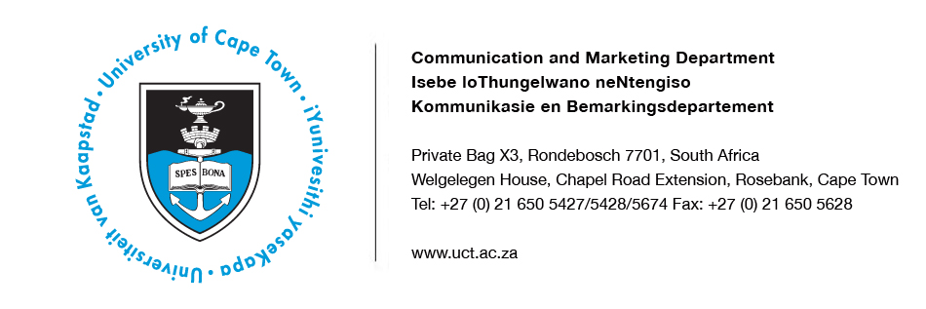
14 January 2014
‘Hip-hop activism’, ‘Toilet wars’ & ‘Peaceful co-existence of science and religion?’
Assortment of exciting lectures and debates on offer at 2014 UCT Summer School, 20 – 31 January 2014, Kramer Law Building, Middle Campus
If you have ever wondered about the role hip-hop has played in engaging South Africans politically and creatively, then the University of Cape Town’s upcoming Summer School course on “Hip-hop activism” might spark your interest. The course by Associate Professor Adam Haupt of UCT’s Centre for Film and Media Studies is one of a range that will be presented at the university’s 64th annual Summer School, held from 20 to 31 January 2014 in the Kramer Law Building, Middle Campus, UCT.
The two-week programme, offered by UCT’s Centre for Open Learning, remains the only programme of its kind in Africa. UCT’s Summer School is an opportunity for members of the public along with UCT alumni, students and staff, to gain access to world-class lecturers, scholarship and research on a wide range of topics.
During a two-day course titled “Politics of poo: The ‘toilet wars’ and the politics of sanitation in Cape Town”, Professor Steven Robins from Stellenbosch University’s Department of Sociology and Social Anthropology will provide an overview of the history of sanitation in Europe, before considering the politics of sanitation in Cape Town. He will focus specifically on the role of the Social Justice Coalition and community activists in transforming sanitation into a highly political matter of public concern.

Debates such as the one between science and religion take a twist as Professor Anwar Mall of UCT’s Division of General Surgery presents arguments in favour of their peaceful and productive coexistence - with science dealing with the “how” of life and religion the meaning.
Ms Medee Rall, Director of UCT’s Centre for Open Learning, says: “Summer School provides a unique opportunity for people of all ages to benefit from the university’s knowledge resources and to have an educationally enriching experience.”
UCT Summer School courses will cover wide-ranging topics including history, art, politics and science, as well as the antikythera mechanism - a 2,000-year old computer. Participants can look at science from every angle – historical, contemporary, practical or theoretical. They can also unravel the ancient mysteries of South Africa’s Mapungubwe heritage site, famous for the golden rhino and other magnificent artefacts, or find out about the financial sustainability of the country’s national parks.
UCT Summer School fees range from R19 to R375. There are no entry requirements and no examinations are written. The programme offers around 60 courses every year and has been running annually since 1950, attracting around 3,000 participants per year.
For the course timetable and details about all courses, visit www.summerschool.uct.ac.za or phone 021 650 2888.

UCT Summer School 2014: Highlights & Speakers
Date | Event | Highlights/Speakers | Contact
20 – 22 January | Science and religion: Friends or foes?  Time: 19h30  Venue: Kramer Law Building, Middle Campus, UCT | During the three-lecture course, Professor Anwar Mall from UCT’s Division of General Surgery will trace the historical relationship between science and religion, explore the “conflict hypotheses” related to them and reflect on the successes of science. | Riana Geldenhuys  Tel: 021 650 4846  riana.geldenhuys@uct.ac.za
24 January | In conversation: Talking transformation  Time: 13h00  Venue: Kramer Law Building, Middle Campus, UCT | Professors Crain Soudien, Deputy Vice-Chancellor on Transformation, UCT, and Jonathan Jansen, Vice-Chancellor, University of the Free State (UFS), will examine the current state of transformation in higher education and its relation to South African society.  They will consider the quest for creative management solutions to the expression of different cultural experiences inside institutions. Professors Soudien and Jansen will also look at the challenges involved in constructing a fully South African reality inside environments that historically were determined by the practices of one group only. | Riana Geldenhuys  Tel: 021 650 4846  riana.geldenhuys@uct.ac.za
27 – 30 January | Hip-hop activism  Time: 17h30  Venue: Kramer Law Building, Middle Campus, UCT | Associate Professor Adam Haupt of UCT’s Centre for Film and Media Studies and DJ Ready D (ex-Prophets of da City) will examine the role hip-hop has played in engaging young South Africans creatively and politically. It will offer an account of hip-hop’s political orientation in relation to debates about commercial co-option, censorship, gender, race and other identity politics. | Riana Geldenhuys  Tel: 021 650 4846  riana.geldenhuys@uct.ac.za
27 – 29 January | The past is unpredictable: SA constitution  Time: 19h30  Venue: Kramer Law Building, Middle Campus, UCT | Professor Pierre de Vos, Claude Leon Foundation Chair in Constitutional Governance at UCT’s Department of Public Law, examines the important ways in which South Africa’s constitution invokes the past, most notably in relation to affirmative action. He will also look at the current upheavals in South Africa’s gender relations as young women, especially lesbians, present challenges to patriarchal norms. Finally Professor De Vos will shed light on civil society’s role in realising the right to education in South Africa. | Riana Geldenhuys  Tel: 021 650 4846  riana.geldenhuys@uct.ac.za
29 January | In conversation: politics–sex/sex–politics  Time: 13h00  Venue: Kramer Law Building, Middle Campus, UCT | This conversation will investigate how space in South Africa’s democracy is being carved by and for women and men who do not conform to gender ideas inherited from apartheid. Dr Christi van der Westhuizen is a feminist, author, award-winning political columnist and research associate with UFS’s Institute for Reconciliation  and Social Justice. She will engage with Dr Zethu Matebeni, activist, author, filmmaker, curator and researcher on  black female sexualities and genders at UCT’s Institute for Humanities in Africa. | Riana Geldenhuys  Tel: 021 650 4846  riana.geldenhuys@uct.ac.za
27 – 31 January | Writers researching: fact and fiction  Time: 17h30  Venue: Kramer Law Building, Middle Campus, UCT | In this course, writers will talk about the research that resulted in their recent novels. Ron Irwin, author of Flat Water Tuesday, will discuss how he researched people, places and real events and the challenges associated with turning the events of one’s own life into a novel. Helen Moffett, one of the trio behind the Girl Walk In series, will explain how she and her co-authors research and write erotica novels, providing insight into collaboration, champagne and condoms. Award-winning Lauren Beukes will describe how she “kinks” reality in relation to the real-world research that informed The Shining Girls and Zoo City. Angela Makholwa will explore the process of writing the criminal mind, including interviews with a serial killer for Red Ink, and research about women who killed their husbands for Black Widow Society. Readers always assume that everything that happened in your book happened to you, complains Finuala Dowling; so, what is the point of trudging uphill for five hours in search of one sentence? Referring to both Homemaking for the Down-at-Heart and her latest manuscript, The Fetch, she discusses the price of authenticity. | Riana Geldenhuys  Tel: 021 650 4846  riana.geldenhuys@uct.ac.za
30 – 31 January | Politics of poo: The ”toilet wars” and the politics of  sanitation in Cape Town  Time: 11h15  Venue: Kramer Law Building, Middle Campus, UCT | Professor Steven Robins of the Department of Sociology and Social Anthropology, Stellenbosch University, presents a two-day lecture series to provide an overview of the history of sanitation in Europe, before he considers the politics of sanitation in Cape Town. The second lecture will focus on the role of the Social Justice Coalition and community activists in transforming sanitation into a highly political matter of public concern. | Riana Geldenhuys  Tel: 021 650 4846  riana.geldenhuys@uct.ac.za

ENDS

Issued by: UCT Communications and Marketing Department
Riana Geldenhuys
Head: Media Liaison
Communication and Marketing Department
University of Cape Town

Tel: (021) 650 4846 Fax: (021) 650 3780
Cell: (082) 460 5554
Email: riana.geldenhuys@uct.ac.za Website: www.uct.ac.za

