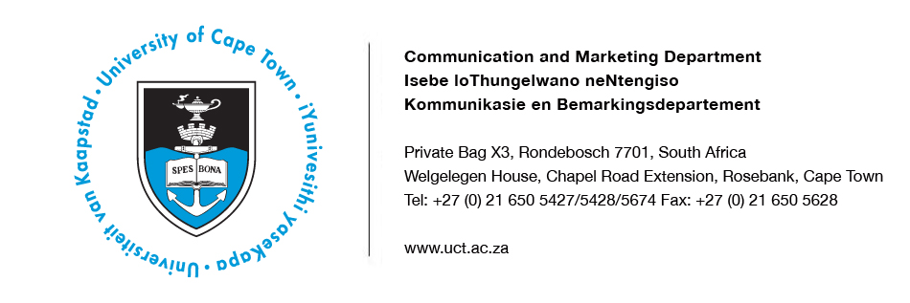
23 April 2014

‘Brazilian keratin type’’ hair-straightening products pose serious health risks – UCT study

Dangerous concentrations of formaldehyde found in seven brands sold in SA

Researchers at the University of Cape Town have found that most commercial “Brazilian keratin type’’ hair-straightening products, tested in a study, contain unacceptably high and dangerous concentrations of formaldehyde.

Formaldehyde exists as a liquid, formalin, in cosmetic products and is unstable in its gaseous state.

The study was published in the Journal of the American Academy of Dermatologists in February 2014. It was led by Associate Professor Nonhlanhla Khumalo in the Division of Dermatology. Dr Mbulelo Maneli did the laboratory work and was assisted by Associate Professor Peter Smith of the Division of Pharmacology.

Brazilian keratin treatment (BKT) and similar hair-straightening products fix and retain a straight shape even when the hair is wet and their popularity is increasing worldwide. A Brazilian mortician is said to have invented the method.

The researchers tested seven brands sold in South Africa at the time of the study. All seven products were advertised as international brands, but the study was unable to confirm that all the tested products were imported from Brazil.

The maximum safe concentration of formaldehyde set by the US Cosmetic Ingredient Review Expert Panel and by most countries, including South Africa, is less than 0.2%. Of the seven commercial BKT brands studied, six had formaldehyde levels that ranged from 0.96% to 1.4%. That is five times higher than the legal limit and these included five brands that were labelled “formaldehyde-free”.

“The concentration of formaldehyde in the products we tested confirms recent international data, this in spite of much media attention and regulatory concern,” the authors say.

They add: “Heat straightens hair by breaking down temporary hydrogen bonds found between keratin filaments, but the effect is lost when the hair gets wet. The convenience and popularity of long-lasting straight hair has resulted in a flood of products. These brands are known by various names.”

Writing in the South African Medical Journal, Associate Professor Khumalo said formaldehyde is associated with eye and skin reactions and adverse pregnancy outcomes.
“It is classified as a carcinogen (or cancer-causing agent). Chronic exposure to high
concentration is associated with respiratory and blood cancers such as leukaemia and lymphomas.”

According to the researchers, high concentrations of formaldehyde, for example in the wood industry, are permitted under strict air control regulations. This is not the case in most hairdressing salons where BKT products are used daily.

The authors say that the study is limited, as they have not been able to include all internationally available BKT products.

“However, the false labelling of products as formaldehyde-free exposes unsuspecting consumers and hairdressers to adverse effects,” the authors add. “Industry monitoring is needed to improve compliance and protection of hairdressers and consumers.”
ENDS

Issued by: UCT Communication and Marketing Department

Kemantha Govender
Media Liaison Officer
Communication and Marketing Department
University of Cape Town
Welgelegen, Upper Chapel Road Extension, Rosebank
Tel: (021) 650 5672 Fax: (021) 650 3780
Cell: (084) 737 6522
E-mail: kemantha.govender@uct.ac.za
Website: www.uct.ac.za

