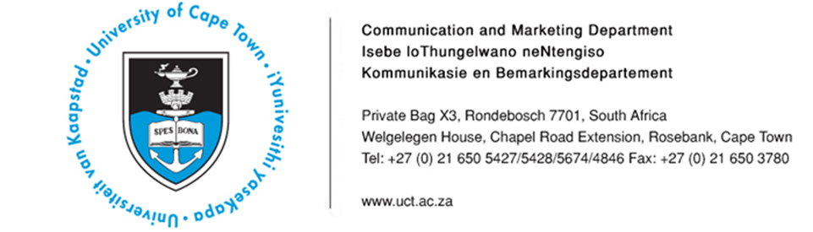

24 March 2014

Upcoming UCT events and interview opportunities
- Mr Bill Frankel, OBE, to receive Vice-Chancellor’s Silver Medal for his services to human rights, constitutionalism, education and philanthropy spanning decades and many continents – including the smuggling into SA of an estimated total of £150m to fund the legal defence of political opponents of apartheid, from 1966 to 1991. This is a good interview for a perspective on 20 Years of Democracy.
- Associate Professor Crick Lund to comment on understanding the complex cyclical relationship between poverty and mental illness in SA and other African countries
- Dr Isabelle Ansorge, Senior Lecturer in UCT’s Oceanography Department, will be supervising a team of Masters students who depart on 2 April 2014 on the SA Agulhas II, to study eddies in the Southern Ocean and their relationship to balancing the planet’s ocean climate.
- Associate Professor Derek Hellenberg, Head of UCT’s Division of Family Medicine, to comment on the success of language courses offered to health services staff members at two Cape Town community health centres

Event/Topic | Highlights/Speakers | Contact
Mr Bill Frankel to receive Vice-Chancellor’s Silver Medal:  Time: 19h00  Date: Tuesday, 25 March 2014  (He is also available at other times of the day.) | Mr Bill Frankel’s many years of enthusiastic philanthropy through the Claude Leon Foundation (he is a grandson of Claude Leon) are helping to increase the volume and quality of research output in South Africa, to ensure the transfer of technical skills and generally enhance the research culture at our universities and technikons, thus contributing to significant research projects that will have a direct impact on people’s lives.  In the 1960s, after graduating from UCT with a Law degree, he was threatened with detention for his political activities. He left the country and joined a London law firm. He was later asked to help the International Defence and Aid Fund for Southern Africa (IDAF) to set up a strategy to smuggle funds into SA for the legal defence of political opponents of apartheid, and did so from 1966 to 1991. He was awarded the OBE in recognition of this service. | Patricia Lucas  Tel: 021 650 5428  Pat.Lucas@uct.ac.za
Understanding the complex cyclical relationship between poverty and mental illness | Associate Professor Crick Lund of the Department of Psychiatry and Mental Health at UCT is the 2014 winner of the Alan Pifer Research Award. The award recognises the impact his research has had on the planning and delivery of neglected mental health services, particularly for poor and vulnerable populations.  Associate Professor Lund says they have found that mental health services in Africa are grossly under-resourced. There is currently approximately one psychiatrist for every 2 million people and one psychologist for every 2.5 million people in Africa. Most ministries of health in Africa spend less than one percent of their meagre health budgets on mental health. Yet there is an emerging and robust evidence base for a range of cost-effective psychological and pharmacological interventions that have health, social and economic benefits, he says.  Associate Professor Lund is the Director of the Alan J Flisher Centre for Public Mental Health. He has played a substantial role in the development and adoption of the Department of Health’s new national Mental Health Policy and Strategic Plan for 2013 to 2020. | Kemantha Govender  Tel: 021 650 5672  Kemantha.Govender@uct.ac.za
Dr Isabelle Ansorge, Senior Lecturer in UCT’s Oceanography Department, will be supervising a team of Masters students who depart on 2 April 2014 on the SA Agulhas II, to study eddies in the Southern Ocean and their relationship to balancing the planet’s ocean climate. | Data collected from this survey will provide information on the exchange in heat and salt fluxes along this eddy corridor, and provide invaluable insight into the adaptability of plankton over time as an eddy relocates southwards introducing waters typical of the Subantarctic into the Antarctic zone. Life on board the SA Agulhas II for Oceanography students is similar to a “class afloat” style experience – students will be expected to attend a series of lectures and tutorials, collect data for mini-projects related to the survey and also work 12-hour shifts in operating all oceanographic instruments. The SA Agulhas II and its predecessor SA Agulhas I continue to provide a unique training platform for UCT Oceanography students to receive hands-on sea-going training. Currently no other research programme exists in which students are given so much responsibility and experience in handling equipment, collecting samples and analysing all data collected during the survey. | Riana Geldenhuys  Tel: 021 650 4846  Riana.Geldenhuys@uct.ac.za
Afrikaans and isiXhosa Communication Skills for Health Professionals Graduation, Delft and Kraaifontein Community Health Centres (CHC)  Date: Thursday, 27 March 2014  Venue 1: Delft CHC, 10h00  Venue 2: Kraaifontein CHC, 12h30 | Associate Professor Derek Hellenberg, Head of UCT’s Division of Family Medicine, is available for comment on the language courses, Afrikaans and isiXhosa Communication Skills for Health Professionals, which UCT offers to address language disparities between staff and patients. Dr Joel Claassen (Afrikaans lecturer) and Mr Zukile Jama (isiXhosa lecturer) are also available for interviews.  These courses are in line with UCT’s objective of introducing isiXhosa and Afrikaans to the undergraduate MBChB curriculum. The courses also form part of the social responsiveness policy positions of both UCT’s Faculties of Health Sciences and Humanities, to implement projects which will strengthen primary care in South Africa.  With funding received from the European Union, the Afrikaans and isiXhosa Communication Skills for Health Professionals courses seek to address one of the key areas of inequity in delivering comprehensive healthcare to South Africa. | Linda Rhoda  Tel: 021 406 6685  Linda.Rhoda@uct.ac.za

ENDS
Issued by: UCT Communication and Marketing Department

Mologadi Makwela
Communication and Marketing Department
University of Cape Town
Tel: (021) 650 5427 Fax: (021) 650 5628
Cell: (078) 258 3965
E-mail: loga.makwela@uct.ac.za
Website: www.uct.ac.za
Follow us on Twitter: @UCT_news

