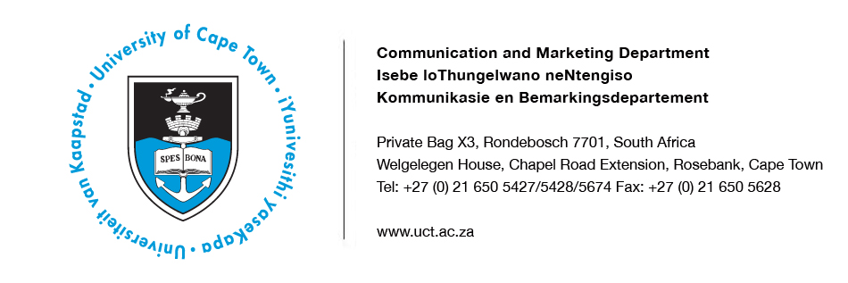
25 March 2014

UCT alumnus named 2014 Stockholm Water Prize Laureate

The University of Cape Town has welcomed the news that UCT alumnus Professor John Briscoe was selected as the 2014 recipient of the prestigious Stockholm Water Prize, also known informally as the “Nobel Prize for Water”. Currently a professor at Harvard University in the United States, Professor Briscoe is honoured by the Stockholm International Water Institute (SIWI) for “his unparalleled contributions to global and local water management, inspired by an unwavering commitment to improving the lives of people on the ground”.

SIWI has been presenting the Stockholm Water Prize annually since 1991 to an individual, organisation or institution, recognising its exceptional water-related achievements. In its citation, the Stockholm Water Prize Committee said Professor Briscoe ”has combined world-class research with policy implementation and practice to improve the development and management of water resources as well as access to safe drinking water and sanitation”.

Born in Brakpan, Gauteng, Professor Briscoe graduated in civil engineering from UCT in 1965, and received his PhD in environmental engineering from Harvard in 1976. He has worked in various countries around the world and lived in South Africa, the United States, Bangladesh, Mozambique, India and Brazil. His scientific expertise includes the areas of engineering, nutrition, epidemiology, demography, anthropology, political science and economics.

One of Professor Briscoe’s many achievements is the 2003 Water Strategy for the World Bank, which is said to have provided “a new, creative and enduring benchmark for global understanding of the need for both better infrastructure and improved institutions”. According to SIWI, this strategy “has had implications far beyond the water sector, helping to ensure that developing and emerging countries get a stronger voice in global governance”.

SIWI has praised Professor Briscoe for “his passionate commitment to sustainable economic development, his disrespect for constructed boundaries between sectors and people, and for his insistence that the voice of people who are affected – from the poorest of farmers, to the private sector, to political leaders – be heard.”

Professor Briscoe said: “It is vital to give primary attention to the effect on people who will live with the consequences of policies and projects. Equally important is the voice of political leaders who have to take account of all of their people and who have to make difficult choices among competing priorities.”

When Professor Briscoe received the news that he had been named the 2014 Stockholm Water Prize Laureate, he was very surprised and honoured. He said: “I am delighted for the recognition this gives to thinking practitioners, of which I consider myself one.” As a professor in the schools of Engineering and Applied Science, Public Health and Government at Harvard, his focus is on educating “the next generation of specialised integrators”.

The Patron of the Stockholm Water Prize, King Carl XVI Gustaf of Sweden, will bestow the prize upon Professor Briscoe at a Royal Award Ceremony during 2014 World Water Week in Stockholm on 4 September 2014. The Stockholm Water Prize Laureate receives US$150,000 and a specially designed crystal sculpture.

PLEASE NOTE: More information about Professor Briscoe, photographs and a video are available at http://www.siwi.org/prizes/stockholmwaterprize/laureates/2014-2/.

ENDS
Issued by: UCT Communication and Marketing Department

Mologadi Makwela
Communication and Marketing Department
University of Cape Town
Tel: (021) 650 5427 Fax: (021) 650 5628
Cell: (078) 258 3965
E-mail: loga.makwela@uct.ac.za
Website: www.uct.ac.za
Follow us on Twitter: @UCT_news

